0AM Mechatronic - Information needed for programming

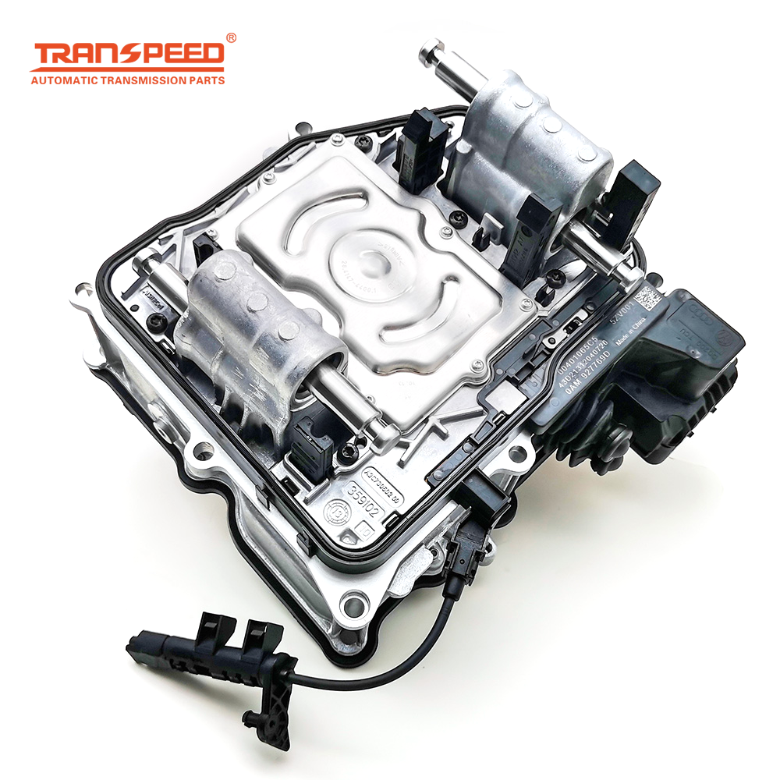
- Car VIN number
e.g. WVWZZZ1KZ9M297341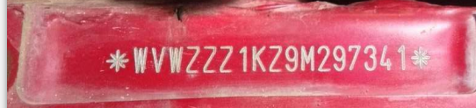

- Car year

- Engine size (1.6L/2.0L...)

- Gear box mid house/case number, see below example: Mainly look at the three letters
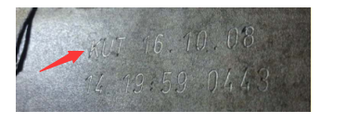
- 41 program date from old TCU, such as below picture
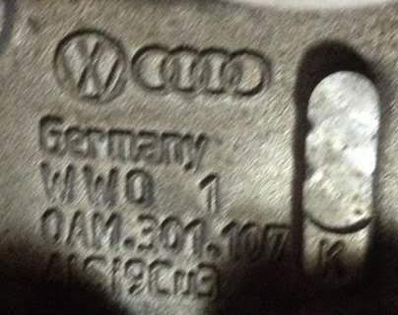
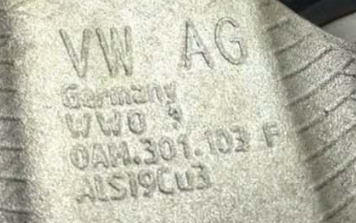
- Car information: VW Golf 7 Speed,1.8 L
Other Picture：
- part number of TCU/ Control Unit
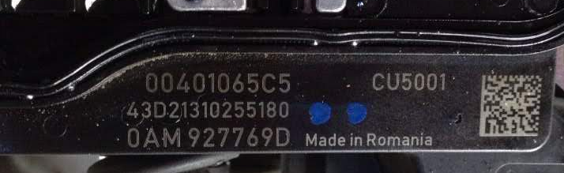2. Car logo
